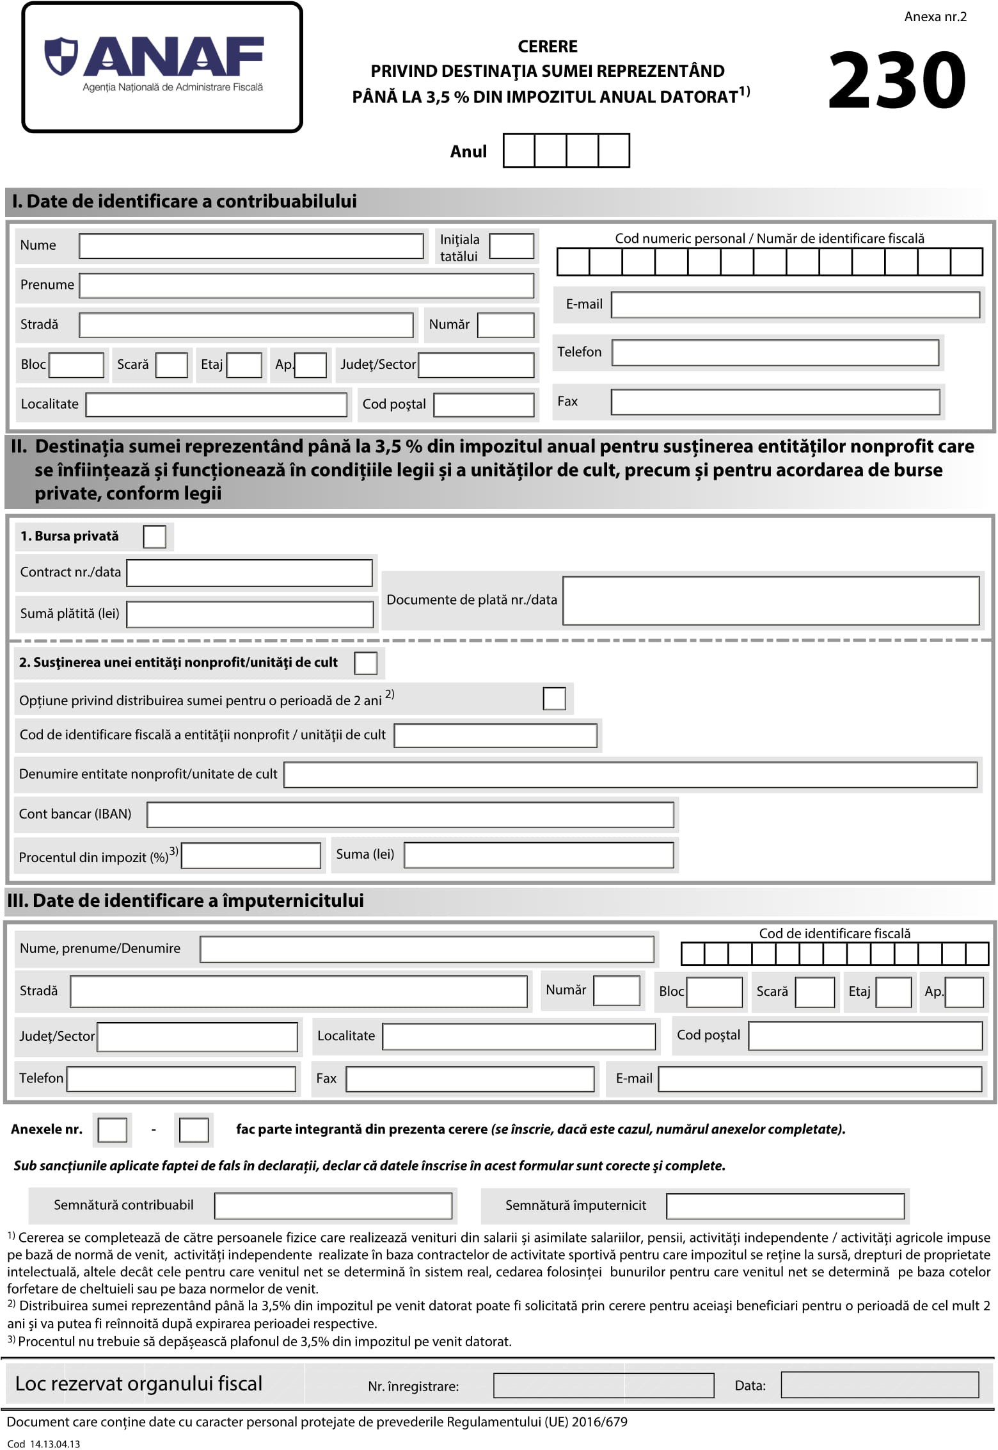
2 0 2 5

x
X
16534153
ASOCIATIA IMPREUNA LA SCOALA
RO71 RNCB 0065 1782 4965 0001

